**Design & Technology**

**Joining Techniques**

**Materials required for questions**

* Pencil
* Rubber
* Calculator

**Instructions**

* Use black ink or ball-point pen
* Try to answer all questions
* Use the space provided to answer questions
* Calculators can be used if necessary
* For the multiple choice questions, circle your answer

**Advice**

* Marks for each question are in brackets
* Read each question fully
* Don’t spend too much time on one question

**Good luck!**

**Q1.** What type of joint provides a strong interlocking join?

**A** Housing

**B** Comb

**C** Mitre

**Q2.** What type of adhesive joins wood to wood?

**A** PVA

**B** Epoxy resin

**C** Contact adhesives

**Q3.** Which method of joining is non-permanent?

**A** Brazing

**B** Arc welding

**C** Nuts and bolts

**Q4.** Which one of the processes below involves the use of heat?

**A** Soldering

**B** Pop riveting

**C** Knock down fittings

**Q5.** What is the name of the component shown below?

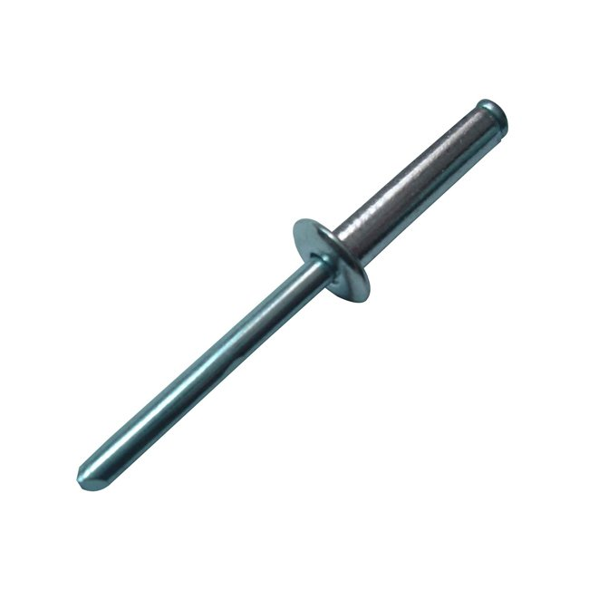

**A** Countersunk head screw

**B** Knock down fitting

**C** Pop rivet

**Q6.** Which method of join is permanent?

**A** Nuts and bolts

**B** Welding

**C** Knock down fitting

**Q7.** What type of joint is the diagram below?

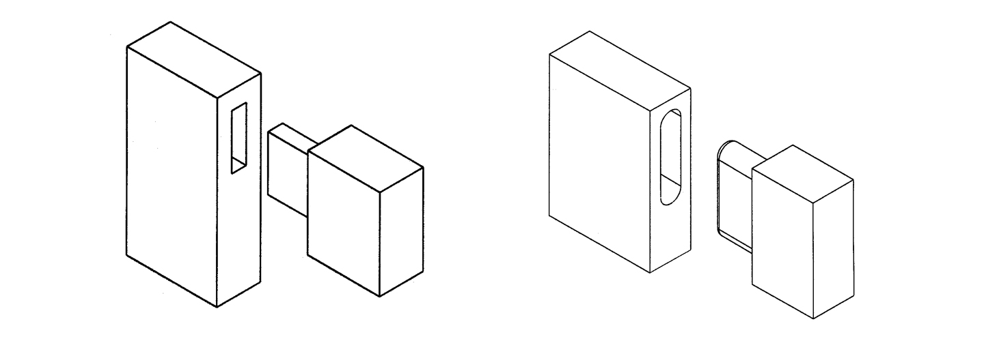

**A** Half lap joint

**B** Mortise and tenon

**C** Dowel joint

**Q8.** Which of the following statements is true?

**A** Brazing needs filler, welding does not

**B** Welding needs filler, brazing does not

**C** Soft soldering produces a equally strong joint than hard soldering

**Q9.** A curved beam has been laminated using an adhesive. Explain **two** reasons why PVA (polyvinyl acetate) adhesive should be used **(4 marks)**

1.

2.

**­**

**Q10.** A bespoke chair has been made using laminated hardwood.



Name **three** joints that could be used to join parts of the chair together **(3 marks)**

1.

2.

3.

**­**

**Q11.** The front wing panel for a mass produced car has been manufactured using sheet steel. It is attached to the steel supporting structure of the car.

Name **three** joining methods that could be used to attach the steel front wing panel to the steel supporting structure of the car during assembly **(3 marks)**

1.

2.

3.

**Q12.** Describe the main stages in the process of soft soldering **(6 marks)**

**Answers**

**Q1.** B **Q2.** A **Q3.** C **Q4.** A **Q5.** C **Q6.** B **Q7.** B

**Q8.** A

**Q9.**

Any **two** valid reasons with linked justification:

* Provides a strong joint (1) so bridge can withstand a lot of weight / last a long time / be durable (1)
* Dries quickly (1) which reduces manufacturing time (1)
* Does not dry instantly (1) which allows time for positioning laminates / clamping in the former (1)
* Water resistant version could be used (1) so suitable for outdoors / close proximity to water (1)
* Requires no mixing / can be used straight out of the bottle (1) reducing waste / time (1)
* Dries clear / does not discolour the wood (1) so cannot be seen / will not detract from aesthetics / beams do not require cleaning / colouring / staining (1)
* Cheap (1) reducing overall costs (1)
* Non-toxic (1) so safe to use / no need for PPE / more environmentally friendly (1)

**Q10.**

**Three** appropriate joints from:

* Mortise and tenon (1)
* Dowel (1)
* Mechanical (screw) fixing (1)
* KD fixings / cross dowels / barrel nuts (1)
* Halving joint (1)
* Dovetail halving joint (1)

**Q11.**

**Three** appropriate joining methods from:

* Welded (1)
* Bolted / machine screwed (1)
* Self-tapping screwed (1)
* Bonded (adhesive) (1)
* Lapped seam (1)
* Riveted (1)

**Q12.**

* The components should be clean and free from grease or impurities (1)
* Flux may be used to help the solder flow and prevent oxidisation when heating. The flux can be added separately or may be present in the core of the solder itself (1)
* The components should be held in place while being heated to approximately 200 degrees Celsius (1)
* Heating can be undertaken with a soldering iron, small gas blow torch or hot air gun depending on the application (1)
* The solder should be added to the joint (1)
* The heat source should be removed and the component or join allowed to cool in order for the solder to return to a solid state (1)
* Any excess flux should be removed to prevent corrosion (1)
* An electrical circuit may be tested after soldering as part of effective quality control (1)
* A solder bath may be used to solder several components to a complete circuit board at one time (1)